DAY -2

# 1.sum of elements in array.

#include<stdio.h>

int main()

{

int sum=0,i,a[5];

printf("enter the numbers in array: ");

for(i=0;i<5;i++)

{

scanf("%d",&a[i]);

}

for(i=0;i<5;i++)

{

sum=sum+a[i];

}

printf("sum of array of elements is : %d",sum);

return 0;

}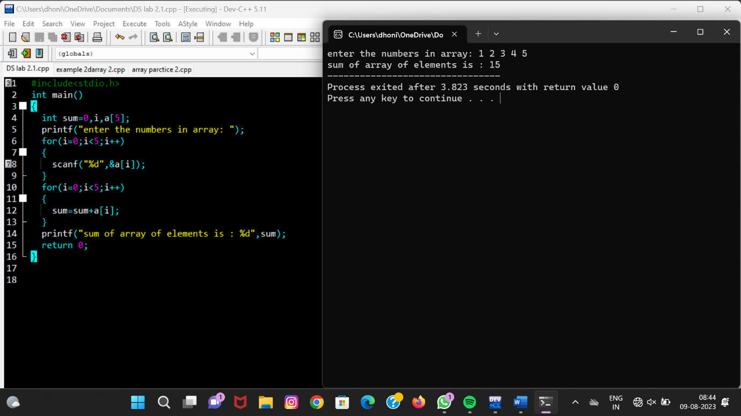

# 2. To merge

#include<stdio.h>

int main()

{

int a[5],b[5],c[10];

int i;

printf("enter the elements array 1: ");

for(i=0;i<5;i++)

{

scanf("%d",&a[i]);

}

printf("enter the elements array 2: ");

for(i=0;i<5;i++)

{

scanf("%d",&b[i]);

}

for(i=0;i<5;i++)

{

c[i]=a[i];

c[i+5]=b[i];

}

{

for(i=0;i<10;i++)

{

printf(" %d ",c[i]);

}

return 0;

}

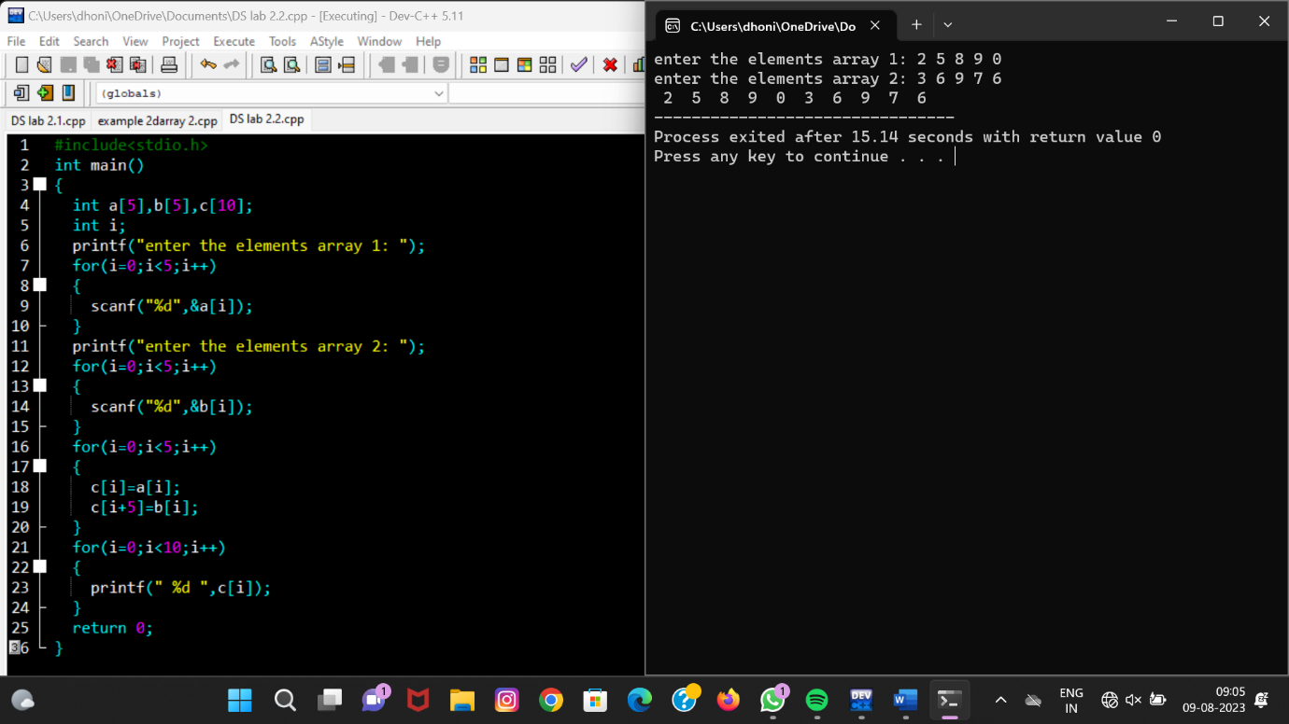

# 3.To perform insertion and deletion in array of elements :

## Insertion of element:

#include<stdio.h>

int main(){

int student[40],pos,i,size,value;

printf("enter no of elements in array of students:");

scanf("%d",&size);

printf("enter %d elements are:",size);

for(i=0;i<size;i++)

scanf("%d",&student[i]);

printf("enter the position where you want to insert the element:");

scanf("%d",&pos);

printf("enter the value into that poition:");

scanf("%d",&value);

for(i=size-1;i>=pos-1;i--)

student[i+1]=student[i];

student[pos-1]= value;

printf("final array after inserting the value is");

for(i=0;i<=size;i++)

printf("%d",student[i]);

return 0;

}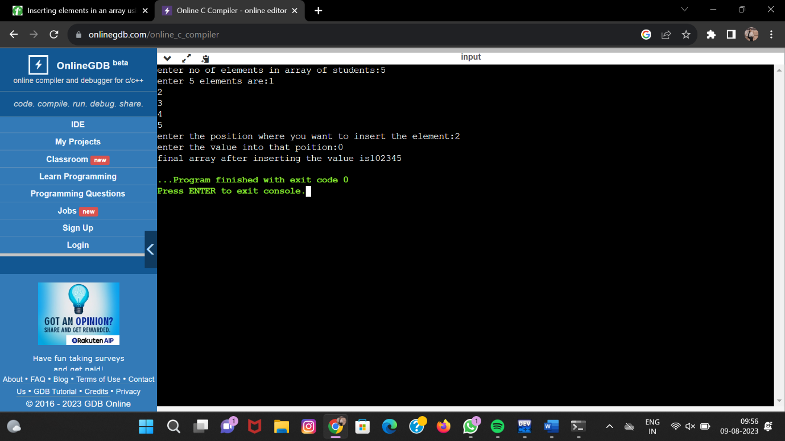

## Deletion of element:

#include <stdio.h>

#include <conio.h>

int main ()

{

int arr[50];

int pos, i, num;

printf (" \n Enter the number of elements in an array: \n ");

scanf (" %d", &num);

printf (" \n Enter %d elements in array: \n ", num);

for (i = 0; i < num; i++ )

{ printf (" arr[%d] = ", i);

scanf (" %d", &arr[i]);

}

printf( " Define the position of the array element where you want to delete: \n ");

scanf (" %d", &pos);

if (pos >= num+1)

{

printf (" \n Deletion is not possible in the array.");

}

else

{

for (i = pos - 1; i < num -1; i++)

{

arr[i] = arr[i+1]; // assign arr[i+1] to arr[i]

}

printf (" \n The resultant array is: \n");

for (i = 0; i< num - 1; i++)

{

printf (" arr[%d] = ", i);

printf (" %d \n", arr[i]);

}

}

return 0;

}

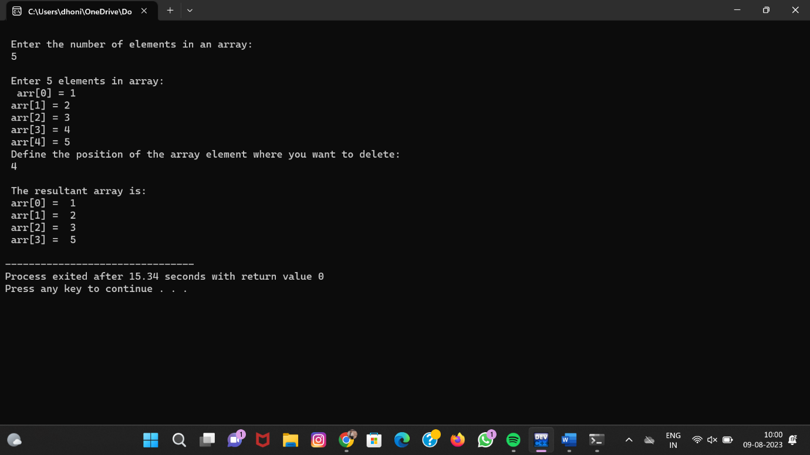

# 4.To Reverse a string:

#include <stdio.h>

#include <string.h>

int main()

{

char str[40];

printf (" \n Enter a string to be reversed: ");

scanf ("%s", str);

printf (" \n After the reverse of a string: %s ", strrev(str));

return 0;

} 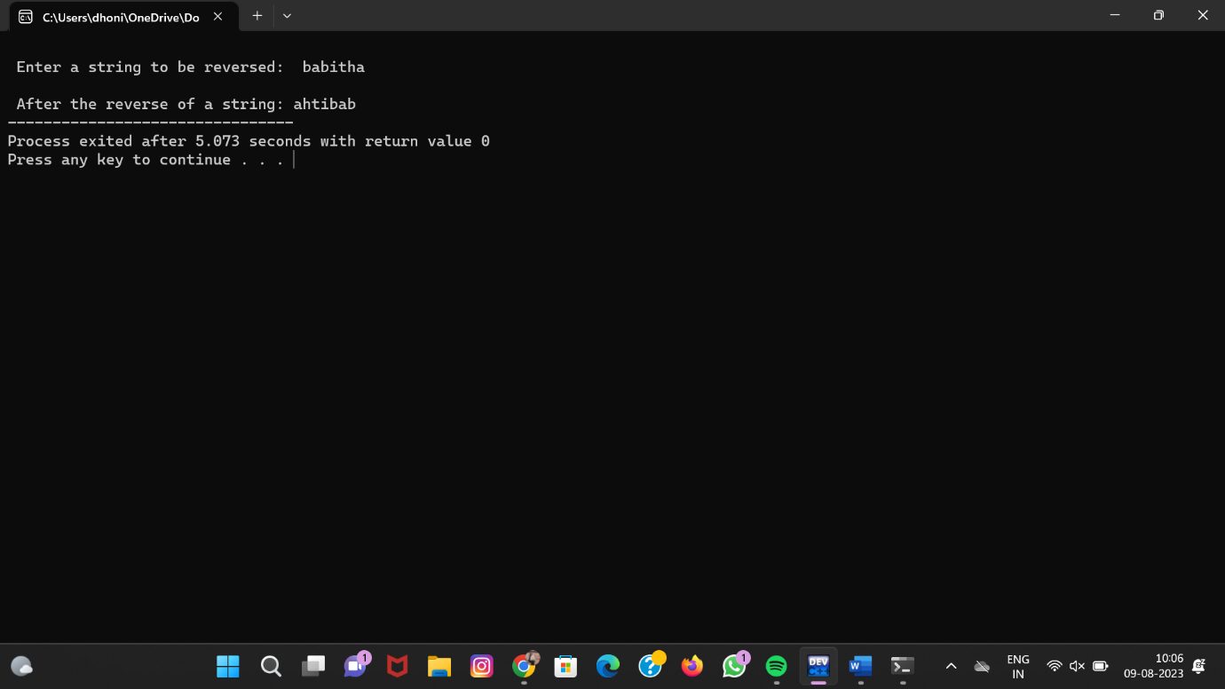

# 5.To check the given string is palindrom or not :

#include<stdio.h>

#include<conio.h>

#include<string.h>

int main() {

char str[20];

int i, len, temp=0;

int flag = 0;

printf("Enter a string:");

scanf("%s", str);

len = strlen(str);

for(i=0; i < len ; i++) {

if(str[i] != str[len-i-1]) {

temp = 1;

break;

}

}

if (temp==0) {

printf("String is a palindrome");

}

else {

printf("String is not a palindrome");

}

Return 0;

} 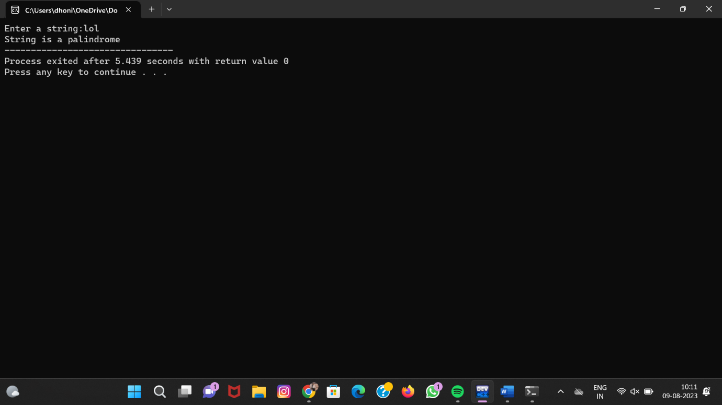

# 6.To search a character in a string:

#include <stdio.h>

#include <string.h>

int main()

{

char s[1000],c;

int i;

printf("Enter the string : ");

gets(s);

printf("Enter character to be searched: ");

c=getchar();

for(i=0;s[i];i++)

{

if(s[i]==c)

{

printf("character '%c' found at location: %d\n ",c,i);

}

}

return 0;

}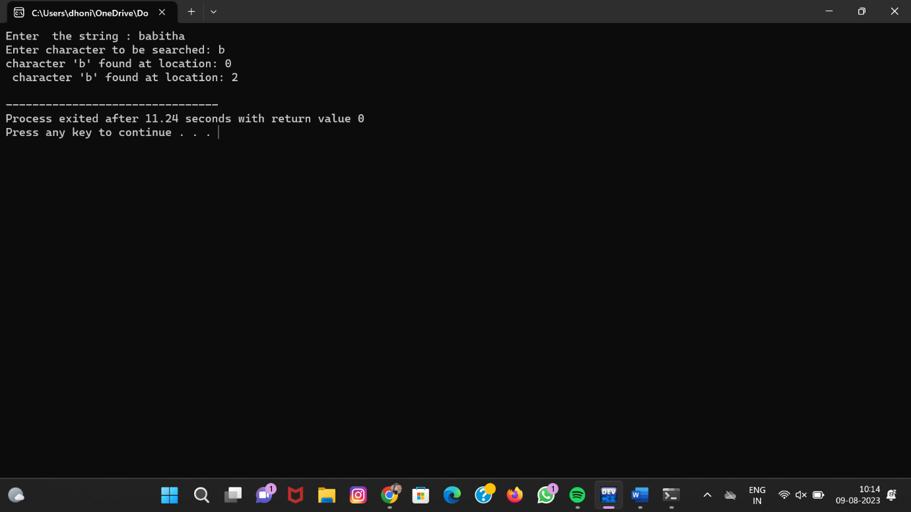

# 7.To count number of vowels in given string:

#include <stdio.h>

int main()

{

int c = 0, count = 0;

char s[1000];

printf("Input a string\n");

gets(s);

while (s[c] != '\0') {

if (s[c] == 'a' || s[c] == 'A' || s[c] == 'e' || s[c] == 'E' || s[c] == 'i' || s[c] == 'I' || s[c] =='o' || s[c]=='O' || s[c] == 'u' || s[c] == 'U')

count++;

c++;

}

printf("Number of vowels in the string: %d", count);

return 0;

}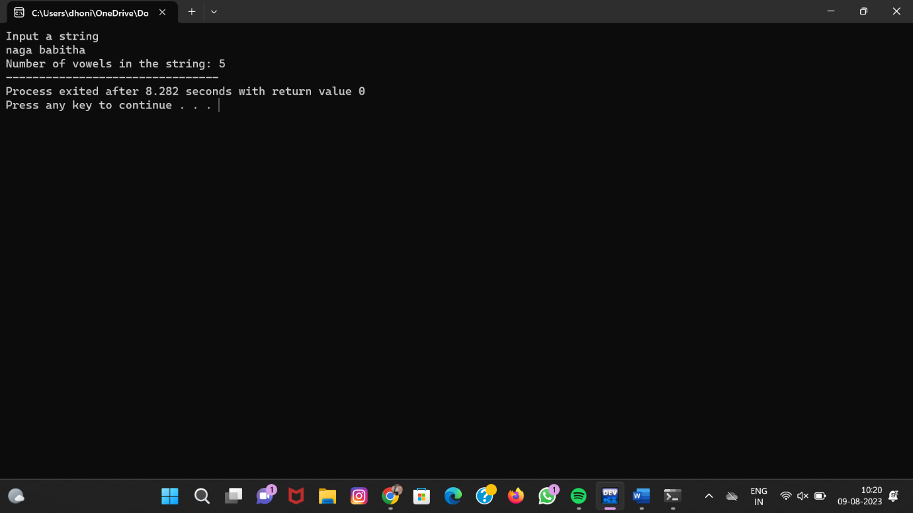

# 8.To perform matrix multiplication :

#include<stdio.h>

#include<stdlib.h>

int main(){

int a[10][10],b[10][10],mul[10][10],r,c,i,j,k;

system("cls");

printf("enter the number of row=");

scanf("%d",&r);

printf("enter the number of column=");

scanf("%d",&c);

printf("enter the first matrix element=\n");

for(i=0;i<r;i++)

{

for(j=0;j<c;j++)

{

scanf("%d",&a[i][j]);

}

}

printf("enter the second matrix element=\n");

for(i=0;i<r;i++)

{

for(j=0;j<c;j++)

{

scanf("%d",&b[i][j]);

}

}

printf("multiply of the matrix=\n");

for(i=0;i<r;i++)

{

for(j=0;j<c;j++)

{

mul[i][j]=0;

for(k=0;k<c;k++)

{

mul[i][j]+=a[i][k]*b[k][j];

}

}

}

//for printing result

for(i=0;i<r;i++)

{

for(j=0;j<c;j++)

{

printf("%d\t",mul[i][j]);

}

printf("\n");

}

return 0;

} 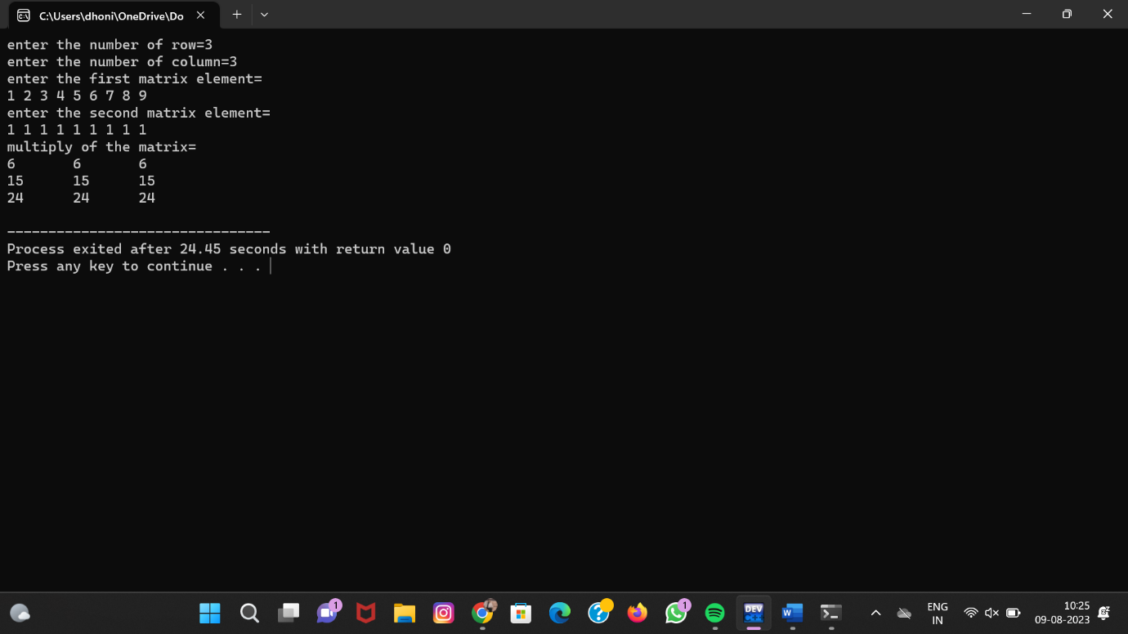

# 9.To perform all string manipulation:

#include <stdio.h>

#include <string.h>

int main() {

char str1[100], str2[100], concat[200];

printf("Enter the first string: ");

scanf("%s", str1);

printf("Enter the second string: ");

scanf("%s", str2);

sprintf(concat, "%s%s", str1, str2);

printf("The concatenated string is: %s\n", concat);

printf("The length of the concatenated string is: %d\n", strlen(concat));

char copy[200];

strcpy(copy, concat);

printf("The copied string is: %s\n", copy);

int result = strcmp(str1, str2);

if (result == 0) {

printf("The two strings are equal.\n");

}

else if (result < 0)

{

printf("The first string is less than the second string.\n");

}

else

{

printf("The first string is greater than the second string.\n");

}

return 0;

}